ISABELLA COUNTY CANVASSING BOARD MEETING

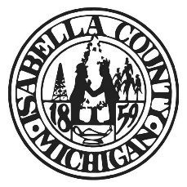

CANVASS OF THE AUGUST 5TH, 2025
SPECIAL ELECTION FOR THE
CITY OF MT. PLEASANT

The Isabella County Canvassing Board will meet to canvass the 2025 Special Election on August 7th, 2025 at 9:00 am. at the City of Mt. Pleasant,
320 West Broadway Street, Mt. Pleasant, MI 48858

Respectfully Submitted,

Minde B. Lux
Isabella County Clerk

