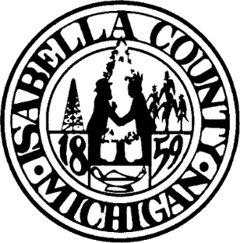
Minde B. Lux, County Clerk
207 Court Street
Mt. Pleasant, MI 48858
Phone (989) 317-4070 MUST ATTACH
www.isabellacounty.org DRIVERS LICENSE
clerk@isabellacounty.org OR STATE I.D.
FOR BIRTH RECORD
Request for a Certified Vital Record ONLY

Please check type of Vital Record

BIRTH __________ DEATH __________ MARRIAGE __________ DIVORCE __________ DBA __________

Name of Person on Requested Record (MUST BE FILLED OUT COMPLETELY TO RECEIVE THE RECORD)

_____________________________________________________________________________________________________
First Name Middle Name Last Name

Date of Event (MUST BE FILLED OUT COMPLETELY_TO RECEIVE THE RECORD)

__________________________________________ # OF DOCUMENTS REQUESTED _______________
Month Day Year
BIRTH, DEATH & MARRIAGE $20.00 FOR THE 1ST CERTIFIED AND $10.00 FOR EACH ADDITIONAL
DBA’S $2.00 EACH FOR A CERTIFIED COPY
DIVORCE $10.00 FOR THE 1ST PAGE CERTIFIED AND $1.00 EACH PAGE AFTER
In Michigan, individuals AGE 65+ pay a reduced fee of $14.00 for the 1st and $7.00 for each additional to purchase their own birth certificate at a county clerk's office. YOU must notify the clerk of your eligibility.
PRINT NAME OF PERSON REQUESTING DOCUMENT: ________________________________________________________

SIGNATURE OF PERSON REQUESTING DOCUMENT:___________________________________DATE: _______________

ADDRESS TO MAIL VITAL RECORD TO:

_____________________________________________________________________________________________________________________

State of Michigan Department of Health and Human Services requires that this application MUST be filled out prior to us checking on a Vital Record. Vital records are publicly available documents, NOT public documents.

FOR OFFICE USE ONLY

IDENTIFICATION USED: _____________________________________________CLERK INITIALS: _______________________
VITAL RECORD SECURITY PAPER #’S __________________________________________________________________________

